Call for Papers on ICCMIT 2017

“Recent Advances in Bio-medical Engineering and Instrumentation”
Organized by:
Dr. Suresh Patil
Professor and Coordinator
Board of Studies, Shivaji University, Kolhapur
Head, Department of Mechanical and Automation Engineering,
A.D.C.E.T., Ashta, Sangli, 416302
E-mail: sureshapatil123@gmail.com, hod_mae@adcet.in

Objectives and Motivation
In current decade, lot of research has led to invent in highly responsive state-of-the-art electronic instrumentation along with its affordability. This has provided the broad scope for implementation of such instrumentation in wide range of applications in advancements of bio-medical systems which enhances the quality of health care processes worldwide.
The conference session entitled “Recent Advances in Bio-medical Engineering and Instrumentation” is the platform to the researchers to exchange their studies and experimentations in the advancements in bio-medical engineering and applications of state-of-the-art electronic instrumentation for the development of improved bio-medical systems.
Scope and Interests
A wide range of areas of advancements in bio-medical engineering and applications of state-of-the-art electronic instrumentation is expected to be presented.
Topics of the session may include, but not limited to, the following:
* Management and analysis of biomedical and health information.
* Applications of information and communication technologies in the practice of healthcare.
* Discovery of new therapies
* New diagnostics techniques
* Bio informatics
* Innovative engineering methods in public healthcare
* Bio-mechanics
* Development of bio-sensors
* Diagnosis and monitoring techniques
* Simulation and Modeling of Biomedical systems
* Use of Smart Sensors and Transducers in Biomedical systems.
* Real-time case studies and analysis
* Bio Signal Processing
* Technology management in the hospital system.
* Automation in Medical processes

* Rehabilitation engineering

BIO-GRAPHY

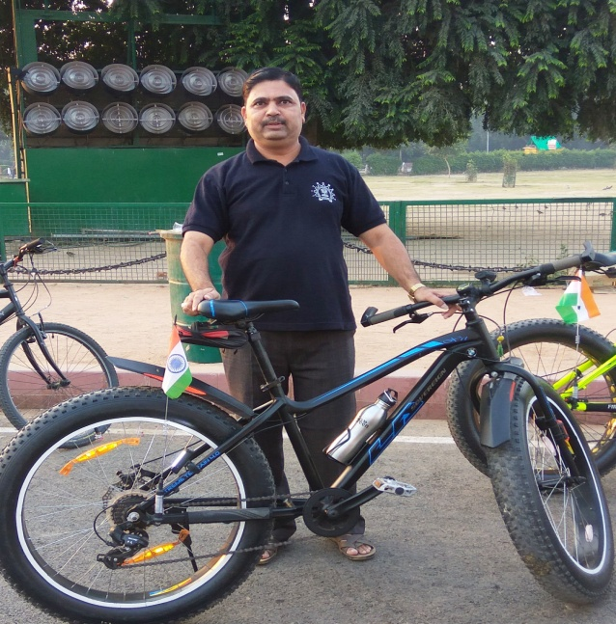
Suresh Patil was born in India in 1971. He received the B.E., M.E., and Ph.D. degrees from Shivaji University, Kolhapur. He is working as Coordinator of Board of Studies of Mechanical and Automation Engineering of Shivaji University, Kolhapur, India.. Since 1997, he has been with the College of Engineering, Sakharale. Currently he is Professor of Engineering.
His main areas of research interest are transformations in Technology, Management and Engineering Education, Ride comfort analysis and biomedical engineering. He has authored 4 engineering reference books.
Dr. Patil is a fellow of the Institution of Engineers of India, the Society of Automotive Engineers and Member and Reviewer of many peer reviewed publications.

